Document version 3.1

Quick Start Power Teacher Guide

Getting Started

- Go to http://www.georgiaoas.org, or go to the PCHS homepage and click on Test Prep Resources Tab and choose Online Assessment System.

- Log on with your teacher ID and password

Creating Classes Manually

Creating classes:
- Select the Classes tab

- Select Create a new class

- Give the class a title and an identifier. (Example: class title – Smith 1st period Geometry; class identifier – smithgeometry1)

- Select the grade level of the student(s) who will be added to the class

- Type in a beginning date and ending date for the class (not required but recommended)

- Click on the name of each student in the class, and click Add. You may add multiple students by holding down the CTRL key and clicking on the student’s name. Click on the name of the teacher(s) associated with the class. A teacher will have access to this class only when his or her name is highlighted.

- Click Submit

- Repeat steps until all classes have been entered

Creating Tests using OAS Item Bank

- From the Teacher Welcome Page, select the

Tests tab
- Select Create a new test

- Give the test a name, a unique test identifier; select any other desired options

- Select a test generation method:
- For teacher-selected, choose Let me choose the questions

- For system-selected, choose Let the system choose the questions for me.

- Specify how student feedback should be provided; for example, correct and incorrect with answers.
- Determine the score ranges for the test and the message the student will see once the test has been scored, or leave the default ranges and messages.
- Click Submit
- Select the subject, grade, and standard(s) to be included in the test:

- If using the teacher-selected method:
- Choose a Subject
- Choose a Grade Level
- Choose a Domain
- Choose a Standard, then an Element, if available.
- Click Show Items
- Put a check mark to the left of any and every item you want included in the test
- Click Add Selected to Test
- Review items on Selected Items Page.
- Remove items, if necessary
- If desired, click Preview Test or add more items by clicking Add Items and repeating steps
- When all items have been selected, click Create Test
- Click Try Test to preview the test
- After trying the test, click Return Home to return to the Teacher Welcome Page

- If using the system-selected method:
- Choose a Subject
- Choose a Grade Level Choose a Standard
- Choose a Standard, then an Element, if available.
- Fill in the number of questions desired for the test

- Click Preview Test
- Preview the test; then click Start Over or Submit

Power Teacher functions con’t

Assigning a Test to a Class
Option 1:

- Select the Classes tab

- Select Assign test(s) to a class

- Select the class to which you want to assign a test

- Click New

- Choose the test(s) you want to assign to the class

- Select any additional options

- Click Submit

Option 2:

- Select the Tests tab

- Select Assign test(s) to class(es)

- Select the class to which you want to assign a test

- Click New

- Choose the test(s) you want to assign to the class

- Select any additional options
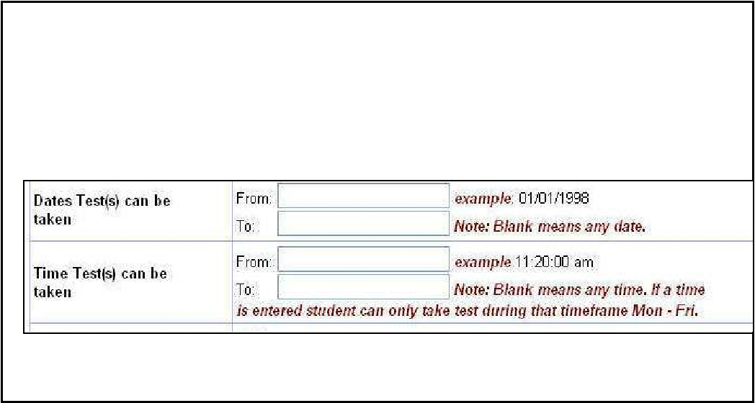
Note: Tests can be assigned on Mondays-Fridays during certain hours by specifying dates and times in the Dates Test(s) can be taken and the Time Test(s) can be taken areas.

- Click Submit

- If Assign Test(s) to individual students was selected, the click to choose the name(s) of the student(s) to whom you want to assign the test, or click Select All, to have the test assigned to every student in the class.

- Click Submit

Scoring Open-Ended Items

- Select the Tests tab.

- Select Score open ended items.

- Click on the name of the test to be scored.

- Click Select.

- Click the students to be scored (or click Select All).

- Click Next.

- Give the student a score for their answer.

- Click Next Student to go to the same question for the next selected student or click Next Question to go to the next question for the same student.

- Click Back when finished scoring.

Viewing Reports

- Select the Reports tab.

- Choose the type of report you want.

- Click on a report name.

- Select the name of the class whose results you want to view.

- Select the name of the test for which you want to view results.

- If necessary, deselect a student (or students) to remove them from the report.

- Click Generate Report.

- Click the Report Menu link to return to the reporting options.

Info on Constructed Response Items:

- Items requiring constructed responses will be located In the Writing Domain for Grades 5, 8, and 12.

- These items are selected and added into a test in the same manner as all other multiple-choice items.

- Sample papers and annotations are located under the Schools link on the logon screen, under Writing Test Sample Papers and Annotations.
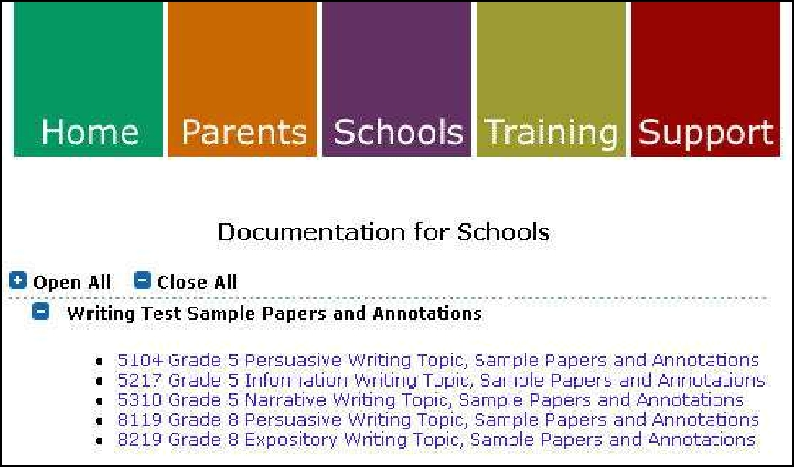

- You will not receive reports for the entire test if you do not manually score these constructed response items.

08.01.2010
page 2

